**WEB TECHNOLOGY LAB**

**PROGRAM1**

Create a web page layout using frames and tables

**frame.html**

<html>

<head>

<title>Web Page Layout Using Frames and Tables</title>

</head>

<frameset cols=50%,50%>

<frameset rows=40%,60%>

<frame src=list1.html>

<frame src=list2.html>

</frameset>

<frame src=tabledts.html>

</frameset>

</html>

**list1.html**

<Html>

<Body bgcolor="green"><H3> LIST OF VEGETABLES </H3> </Body>

<OL>

<LI> TOMATO </LI>

<LI> BEET ROOT </LI>

<LI> CABBAGE </LI>

<LI> BROCCOLI</LI>

<LI> BRINGAL </LI>

</OL>

</Html>

**list2.html**

<Html>

<Body bgcolor="yellow"><H3>LIST OF FRUITS </H3> </Body>

<UL>

<LI> APPLE </LI>

<LI> ORANGE </LI>

<LI> MANGO </LI>

<LI> BANANA </LI>

<Li> CHERRY </LI>

</UL>

**tabledts.html**

<html>

<Body bgcolor="brown"><H3>STUDENT DETAILS </H3> </Body>

<table border=1>

<tbody>

<tr>

<th>REG.NO</th>

<th>NAME</th>

<th>CLASS</th>

<th>MARK1</th>

<th> MARK2</th>

<th>MARK3</th>

</tr>

<tr>

<td>21UCIT001</td>

<td> ANU</td>

<td>II B.Sc.IT</td>

<td>87</td>

<td>45</td>

<td>78</td>

</tr>

<tr>

<td>21UCIT002</td>

<td> ABI</td>

<td>II B.Sc.IT</td>

<td>97</td>

<td>55</td>

<td>88</td>

</tr>

</tbody>

</table>

</html>

**OUTPUT**

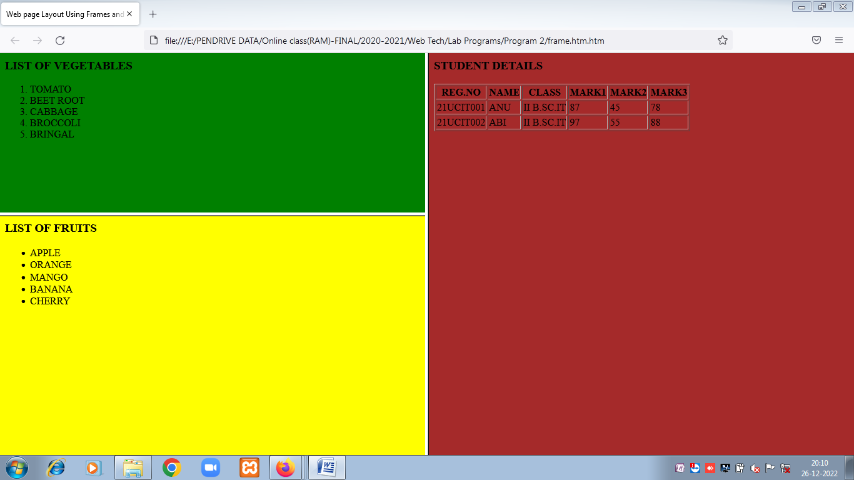

PROGRAM 2

Create a HTML file by applying different styles using inline, external and internal styles.

**stylesheet.css**

<style>

h2 {color:maroon; font-size:20pt}

hr {color:navy}

p {font-size:11pt; margin-left: 15px}

a:link {color:green}

a:visited {color:yellow}

a:hover {color:black}

a:active {color:blue}

</style>

**stylesheet.htm (file name)**

<head>

<link rel="stylesheet" type="text/css" href="stylesheet.css" />

<style type="text/css">

body

{

margin-left:200px;

background:blue

}

.container

{

text-align:center;

}

.center_div

{

border:1px solid gray;

margin-left:auto;

margin-right:auto;

width:90%;

background-color:orange;

text-align:center;

padding:8px;

}

li

{

text-decoration:line-through;

padding:20px;

}

</style>

</head>

<body>

<div class="container">

<div class="center_div">

<h1>WELCOME TO CASCADING STYLE SHEET!!!!!!</h1>

</div>

</div>

<p style="border-style:dotted solid dashed double"><font color="red">HTML stands for HyperText Markup Language.<br>It is the predominant markup language for creating web pages.<br>

HTML is not a programming language, it is a markup language which contains a set of markup tags.<br>HTML tags normally come in pairs like tags. The first tag in a pair is the start tag, the second tag is the end tag (they are also called opening tags and closing tags).

The purpose of a web browser is to read HTML documents and display them as web pages.<br> The browser does not display the HTML tags, but uses the tags to interpret the content of the page.

HTML elements form the building blocks of all websites.<br>HTML allows images and objects to be embedded and can be used to create interactive forms. <br>

</p> </font>

<p style="border-style:dotted solid dashed"><font color="orange">HTML STANDS FOR HYPERTEXT MARKUP LANGUAGE.</font></p>

<p style="border-style:dotted solid"><font color="darkgreen">XML stands for Extensible Markup Language</font></p>

<p style="border-style:dotted"><font color="yellow">CSS stands for Cascading Style Sheet</font></p>

<p><H3><center><a href="cd_catalog.xml" target="_blank">CLICK HERE</a></H3></center></p>

<H3><U>CSS STYLES</U></H>

<UL>

<Li> INTERNAL STYLE SHEET </Li>

<Li> EXTERNAL STYLE SHEET</Li>

<Li>INLINE STYLE SHEET </Li>

</UL>

</body>

</html>

**OUTPUT**

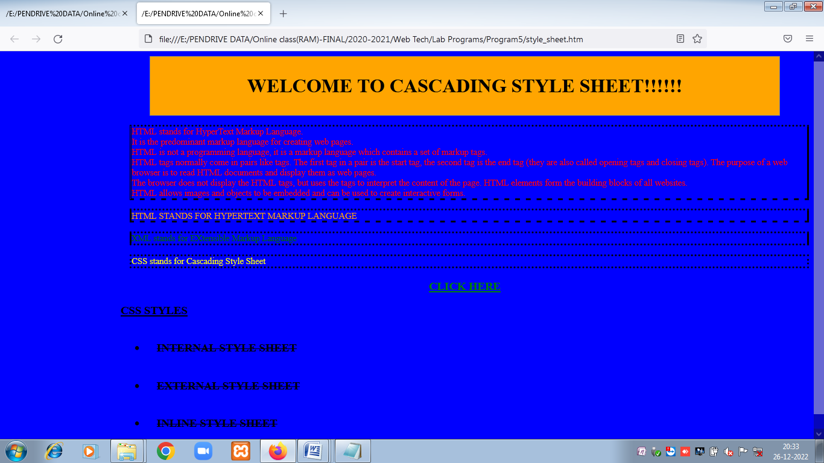

PROGRAM 3

Write a Javascript program to define a function for sorting the values in an array.

**sorting.html**

<html>

<head>

<script type="text/javascript">

var num=0;

number=0;

var numarray=new Array();

function array_size()

{

num=prompt("Enter how many number to be sorted","000");

number=parseInt(num);

get_numbers();

}

function get_numbers()

{

if (number!=null && number!="")

{

for( i=0;i<number;i++)

{

n=prompt("Enter the number to be sorted","1");

numarray[i]=parseInt(n);

}

}

sorting()

}

function sorting()

{

document.writeln("<h1>Sorted Array is <h1>");

document.writeln(numarray.sort(sortNumber));

}

function sortNumber(a,b )

{

return a - b;

}

</script>

</head>

<body>

<h1> Click the button to get the Number sorted</h1>

<input type="button" onclick="array_size()" value="Get Array Size" />

</body>

</html>

**OUTPUT**

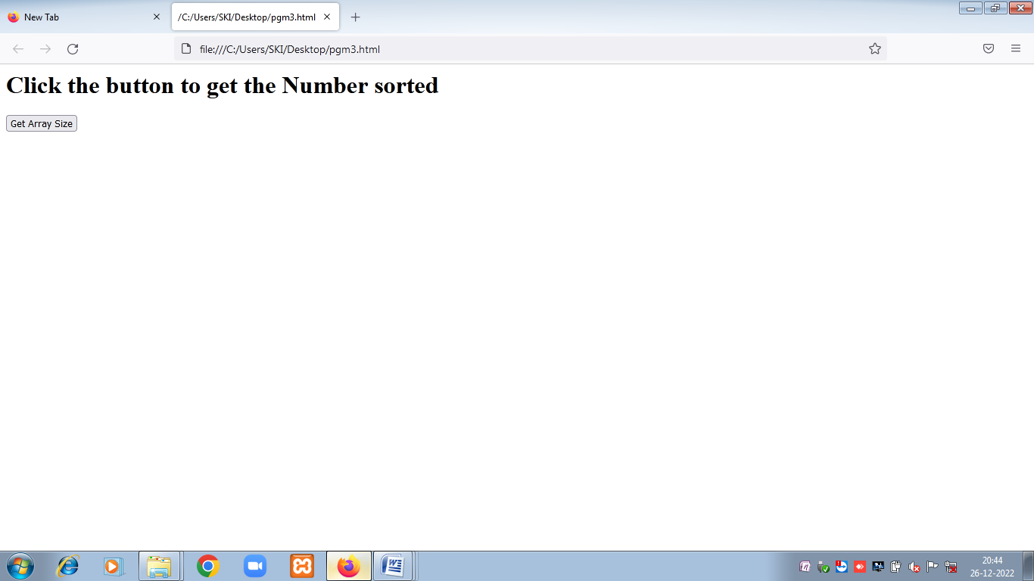

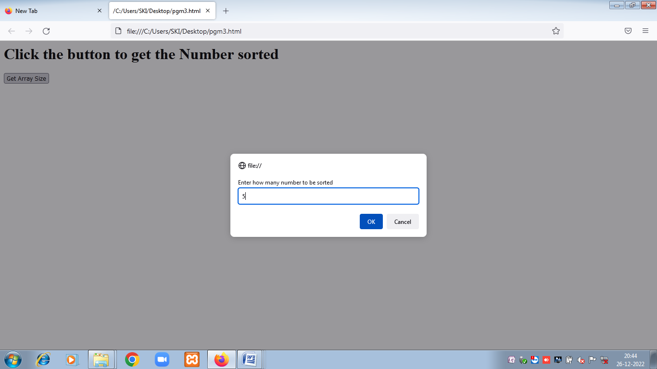

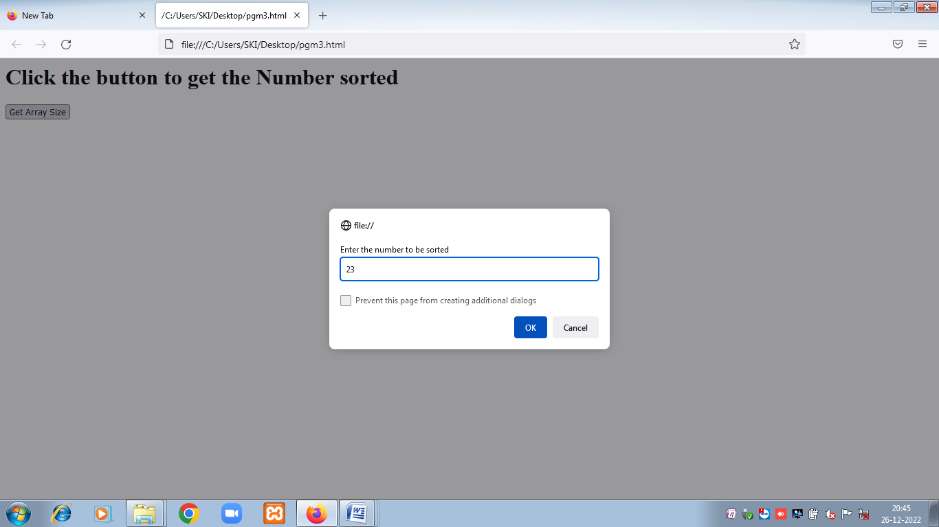

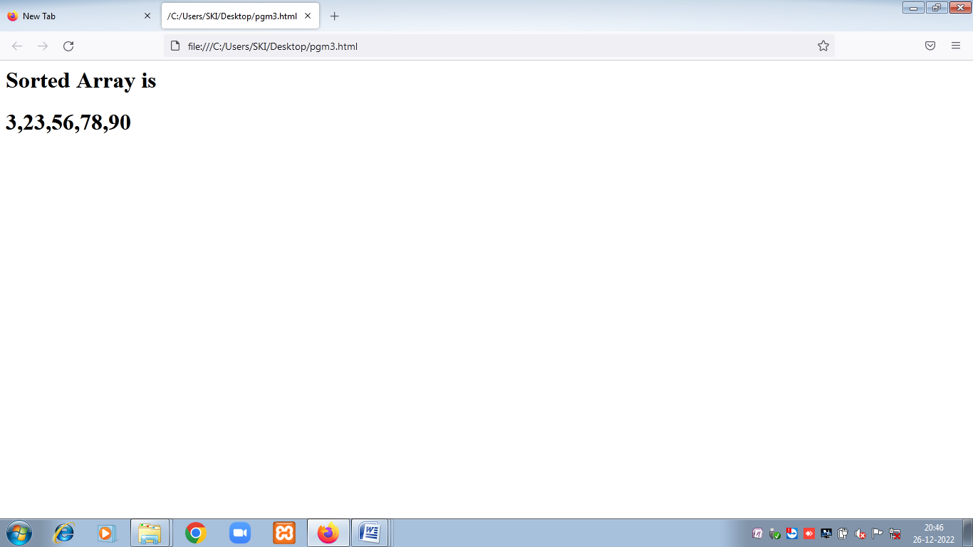

**4. Create a password strength checker using jQuery**

<html>

<head>

<style>

#password-strength-status {

padding: 5px 10px;

border-radius: 4px;

margin-top: 5px;

}

.medium-password {

background-color: #fd0;

}

.weak-password {

background-color: #FBE1E1;

}

.strong-password {

background-color: #D5F9D5;

}

</style>

<script src="https://code.jquery.com/jquery-2.1.1.min.js"

type="text/javascript"></script>

<script type="text/javascript">

function checkPasswordStrength() {

var number = /([0-9])/;

var alphabets = /([a-zA-Z])/;

var special_characters = /([~,!,@,#,$,%,^,&,*,-,_,+,=,?,>,<])/;

var password = $('#password').val().trim();

if(password.length<6) {

$('#password-strength-status').removeClass();

$('#password-strength-status').addClass('weak-password');

$('#password-strength-status').html("Weak (should be atleast 6 characters.)");

} else {

if(password.match(number) && password.match(alphabets) && password.match(special_characters)) {

$('#password-strength-status').removeClass();

$('#password-strength-status').addClass('strong-password');

$('#password-strength-status').html("Strong");

}

else {

$('#password-strength-status').removeClass();

$('#password-strength-status').addClass('medium-password');

$('#password-strength-status').html("Medium (should include alphabets, numbers and special characters.)");

}

}

}

</script>

</head>

<body>

<div class="phppot-container tile-container">

<h2 class="text-center">Password Strength Checker</h2>

<form>

<div class="row">

<label>Password:</label> <input type="password"

name="password" id="password" class="full-width"

onkeyup="checkPasswordStrength();" />

</div>

<div id="password-strength-status"></div>

</form>

</div>

</body>

</html>

Output:

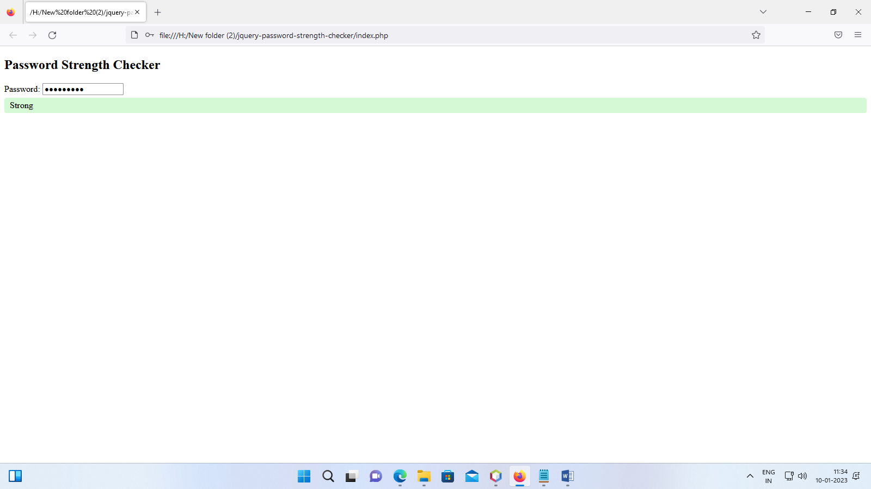

5. To create a servlet program to retrieve the values entered in the html file.

**Index.html**

<html>

<head>

<title> Retrieving the values entered in the html file </title>

<meta charset="UTF-8">

<meta name="viewport" content="width=device-width, initial-scale=1.0">

</head>

<body>

<form name="loginForm" method="post" action="S2">

Register Number: <input type="text" name="r1" /><br><br>

Name: <input type="text" name="n1"/><br><br>

Mark1 : <input type="text" name="m1"/><br><br>

Mark2 : <input type="text" name="m2"/><br><br>

Mark3 : <input type="text" name="m3"/><br><br>

<input type="submit" value="SUBMIT" />

</form>

</body>

</html>

**Servlet file (S2.java)**

import java.io.IOException;

import java.io.PrintWriter;

import javax.servlet.*;

import javax.servlet.annotation.WebServlet;

import javax.servlet.http.HttpServlet;

import javax.servlet.http.HttpServletRequest;

import javax.servlet.http.HttpServletResponse;

@WebServlet(urlPatterns = {"/S2"})

public class S2 extends HttpServlet {

public void init(ServletConfig config) throws ServletException {

super.init(config);

}

protected void processRequest(HttpServletRequest request, HttpServletResponse response)

throws ServletException, IOException {

response.setContentType("text/html;charset=UTF-8");

try ( PrintWriter out = response.getWriter()) {

String r,n,m1,m2,m3;

/* TODO output your page here. You may use following sample code. */

out.println("<!DOCTYPE html>");

out.println("<html>");

out.println("<head>");

out.println("<title>Servlet S2</title>");

out.println("</head>");

out.println("<body>");

out.println("<h1>STUDENT MARK STATEMENT</h1>");

out.println("<table border=1><th>S.No</th><th>Reg. No.</th><th>Name</th><th>Mark 1</th><th>Mark 2</th><th>Mark 3</th>");

r=request.getParameter("r1");

n=request.getParameter("n1");

m1=request.getParameter("m1");

m2=request.getParameter("m2");

m3=request.getParameter("m3");

out.println("<tr><td>1</td><td>"+r+"</td><td>"+n+"</td><td>"+m1+"</td><td>"+m2+"</td><td>"+m3+"</td></tr>");

out.println("</table>");

out.println("</body>");

out.println("</html>");

out.close();

}

}

@Override

protected void doGet(HttpServletRequest request, HttpServletResponse response)

throws ServletException, IOException {

processRequest(request, response);

}

@Override

protected void doPost(HttpServletRequest request, HttpServletResponse response)

throws ServletException, IOException {

processRequest(request, response);

}

@Override

public String getServletInfo() {

return "Short description";

}

}

Output:

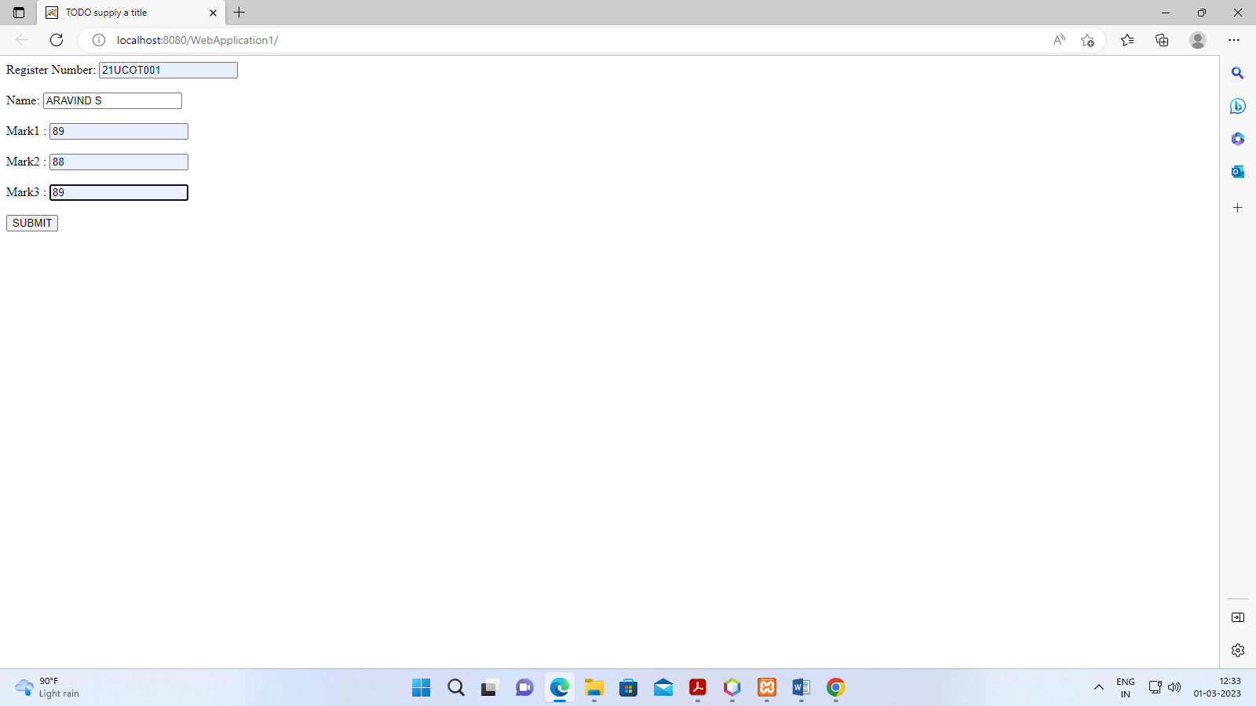

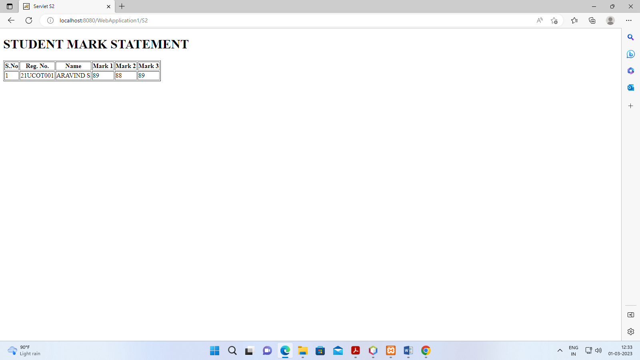

**PROGRAM-6**

**Develop online applications using java server pages.**

**index.jsp**

<%@page contentType="text/html"%>

<html>

<head><title>Online Application</title></head>

<body>

<h1>ONLINE APPLICATION</H1>

<form name="myform" action="display.jsp" method="POST">

<table border="0">

<tr>

<td>First Name:</td>

<td><input type="text" name="first" value="" size="50">

</td>

</tr>

<tr>

<td>Last Name:</td>

<td><input type="text" name="last" value="" size="50">

</td>

</tr>

<tr>

<td>Email Address:</td>

<td><input type="text" name="email" value="" size="50">

</td>

</tr>

<tr>

<td>Gender:</td>

<td><select name="gender">

<option>Male</option>

<option> Female<option>

</select>

</td>

</tr>

<tr>

<td>Date of Birth:</td>

<td><input type="text" name="dob" value="dd/mm/yyyy" size="50">

</td>

</tr>

<tr>

<td>

<input type="reset" value="Clear" name="clear">

<input type="submit" value="Submit" name="submit">

</td>

</tr>

</table>

</form>

</body>

</html>

**display.jsp**

<%@page contentType="text/html"%>

<html>

<head><title>Using Forms</title></head>

<body>

<h1 align="center"> RESULT PAGE<h1>

<% String firstname=request.getParameter("first");

String lastname=request.getParameter("last");

String emailaddress=request.getParameter("email");

String gender=request.getParameter("gender");

String dob=request.getParameter("dob");

%>

<table border="1" align="center">

<tr>

<td> First Name:</td>

<td><%=firstname%></td>

</tr>

<tr>

<td> Last Name:</td>

<td><%=lastname%></td>

</tr>

<tr>

<td> Email Address</td>

<td><%=emailaddress%></td>

</tr>

<tr>

<td> Gender:</td>

<td><%=gender%></td>

</tr>

<tr>

<td> Date of Birth:</td>

<td><%=dob%></td>

</tr>

</table>

</body>

</html>

**Output**

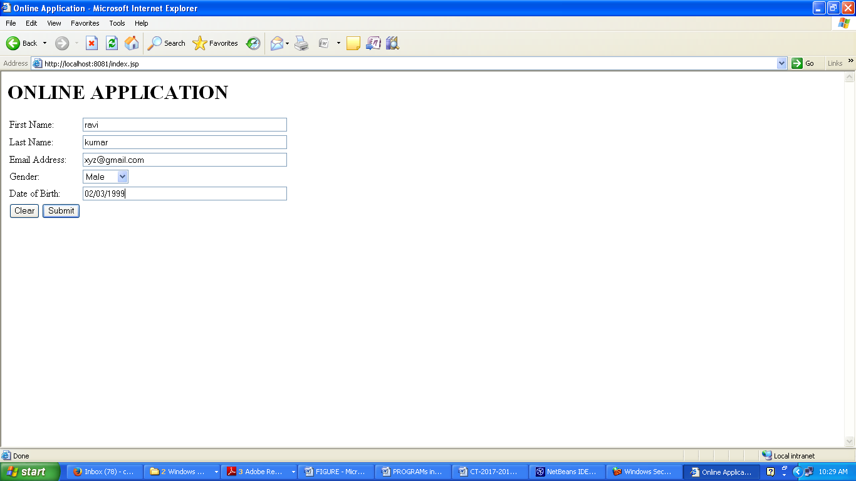

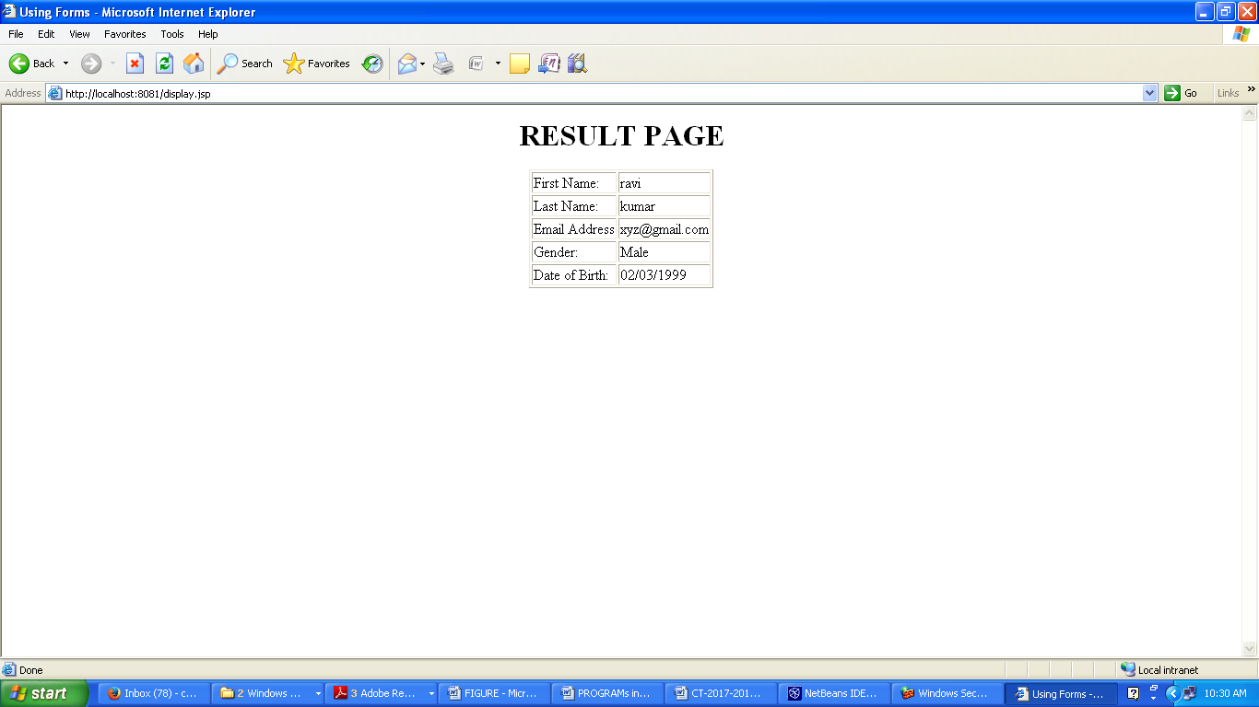

7.Create XML file using XSL style sheet.

**Bookdts.xml**

<?xml version="1.0" ?>

<?xml-stylesheet type="text/xsl" href="sheet.xsl"?>

<!DOCTYPE book [

<!ELEMENT note (bookname,author,price)>

<!ELEMENT bookname (#PCDATA)>

<!ELEMENT author (#PCDATA)>

<!ELEMENT price (#PCDATA)>

]>

<catalog1>

<book>

<bookname> A preview of active server pages </bookname>

<author> Richard Anderson</author>

<price> Rs.500 </price>

</book>

<book>

<bookname> Let Us C </bookname>

<author> Yeshvant Kanitkar </author>

<price> Rs.375 </price>

</book>

<book>

<bookname> C and Data Structures </bookname>

<author> Ashok N. Kamathane </author>

<price> Rs.400 </price>

</book>

<book>

<bookname> ANSI C </bookname>

<author> E.Balagurusamy </author>

<price> Rs.500 </price>

</book>

</catalog1>

**sheet.xsl**

<?xml version="1.0" ?>

<xsl:stylesheet version="1.0" xmlns:xsl="http://www.w3.org/1999/XSL/Transform">

<xsl:template match="/">

<html>

<body>

<h1>Computer Books </h1>

<table border="1">

<tr bgcolor="green">

<th>Book Name</th>

<th>Author Name</th>

<th>Price</th>

</tr>

<xsl:for-each select="catalog1/book">

<tr>

<td><xsl:value-of select="bookname" /></td>

<td><xsl:value-of select="author" /></td>

<td><xsl:value-of select="price" /></td>

</tr>

</xsl:for-each>

</table>

</body>

</html>

</xsl:template>

</xsl:stylesheet>

**output**

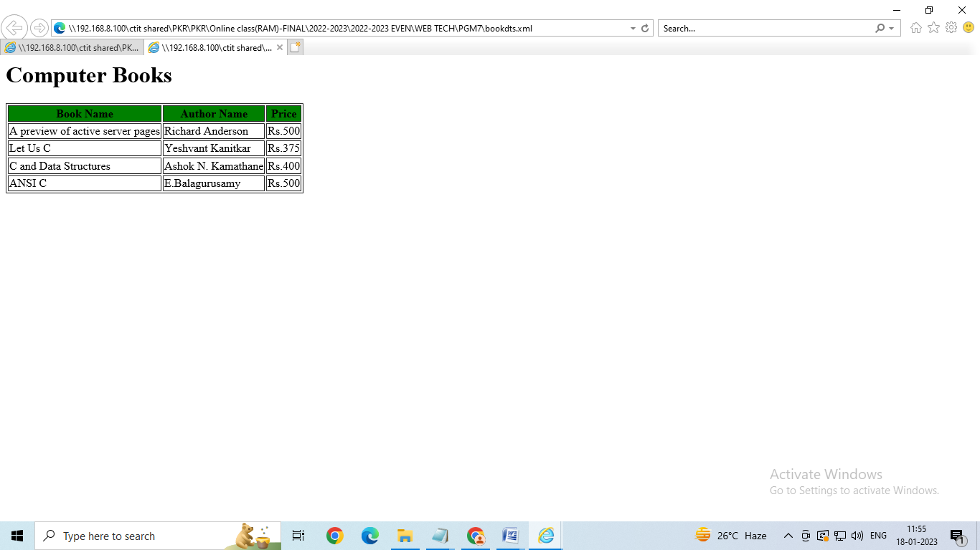

8.

**Studentdetails.xml**

<?xml version="1.0" encoding="UTF-8"?>

<?xml-stylesheet type="text/css" href="Rule.css"?>

<studentdetails>

<heading>Student Personal Details </heading>

<student>

<name>Name -: ARAVIND S</name>

<registernumber>Register Number -: 17UCOT001</registernumber>

<dob>Date of Birth -: 13.07.1994</dob>

<emailid>Email id -: arvinds@gmail.com</emailid>

<phoneno> Phone Number -: 99663526544 </phoneno>

</student>

<student>

<name>Name -: ARULKUMAR M s</name>

<registernumber>Register Number -: 17UCOT002</registernumber>

<dob>Date of Birth -: 22.08.1994</dob>

<emailid>Email id -: arulkumarm@gmail.com</emailid>

<phoneno> Phone Number -: 9988775544 </phoneno>

</student>

</studentdetails>

**Rule.css**

students {

color: white;

background-color : gray;

width: 100%;

}

heading {

color: green;

font-size : 40px;

background-color : powderblue;

}

name, registernumber, dob, emailid, phoneno {

display : block;

color: red;

font-size : 20px;

background-color : blue;

}

title {

font-size : 25px;

font-weight : bold;

}

Output :

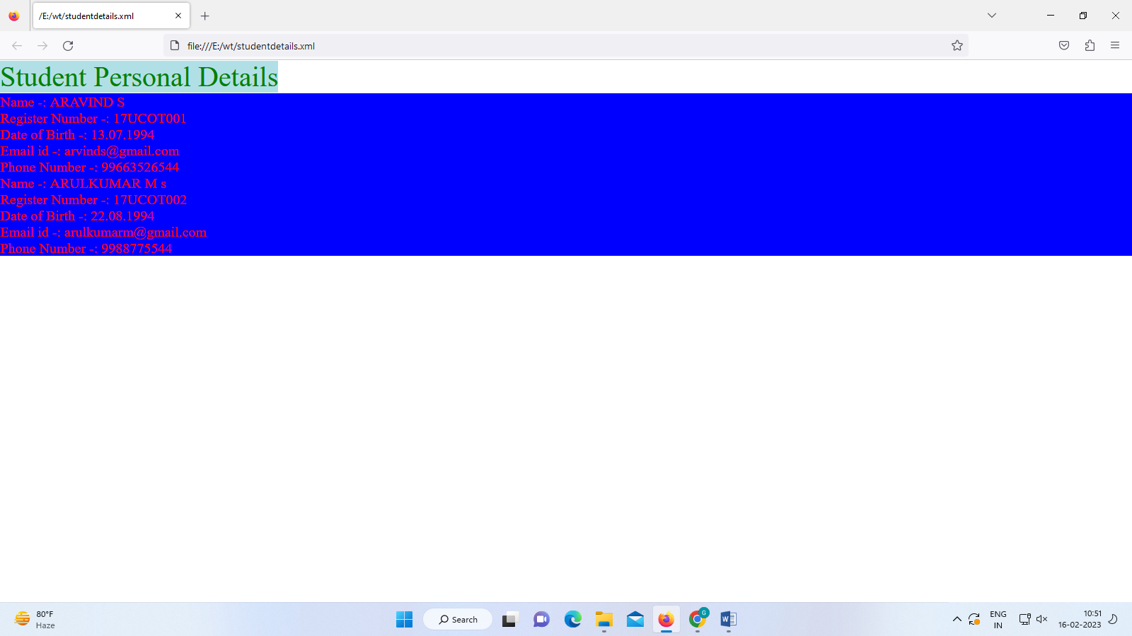

9. Design a simple calculator using php.

<!DOCTYPE html>

<html>

<body>

<?php

ini_set('display_errors',0);

if( isset( $_REQUEST['calculate'] ))

{

$operator=$_REQUEST['operator'];

$n1 = $_REQUEST['first_value'];

$n2 = $_REQUEST['second_value'];

if($operator=="+")

{

$res= $n1+$n2;

}

if($operator=="-")

{

$res= $n1-$n2;

}

if($operator=="*")

{

$res =$n1*$n2;

}

if($operator=="/")

{

$res= $n1/$n2;

}

if($_REQUEST['first_value']==NULL || $_REQUEST['second_value']==NULL)

{

echo "<script language=javascript> alert(\"Please Enter Correct values.\");</script>";

}

}

?>

<form>

<table >

<tr>

<td>Enter Number</td>

<td colspan="1">

<input name="first_value" type="text" style="color:red"/></td>

</tr>

<tr>

<td>Select Operator</td>

<td>

<select name="operator" style="width: 63px">

<option>+</option>

<option>-</option>

<option>*</option>

<option>/</option>

</select></td>

</tr>

<tr>

<td>Enter Number</td>

<td class="auto-style5">

<input name="second_value" type="text" style="color:red"/></td>

</tr>

<tr>

<td></td>

<td><input type="submit" name="calculate" value="Calculate" style="color:wheat;background-color:rosybrown" /></td>

</tr>

<tr>

<td>Output = </td>

<td><?php echo $res;?></td>

</tr>

</table>

</form>

</body>

</html>

**Output :**

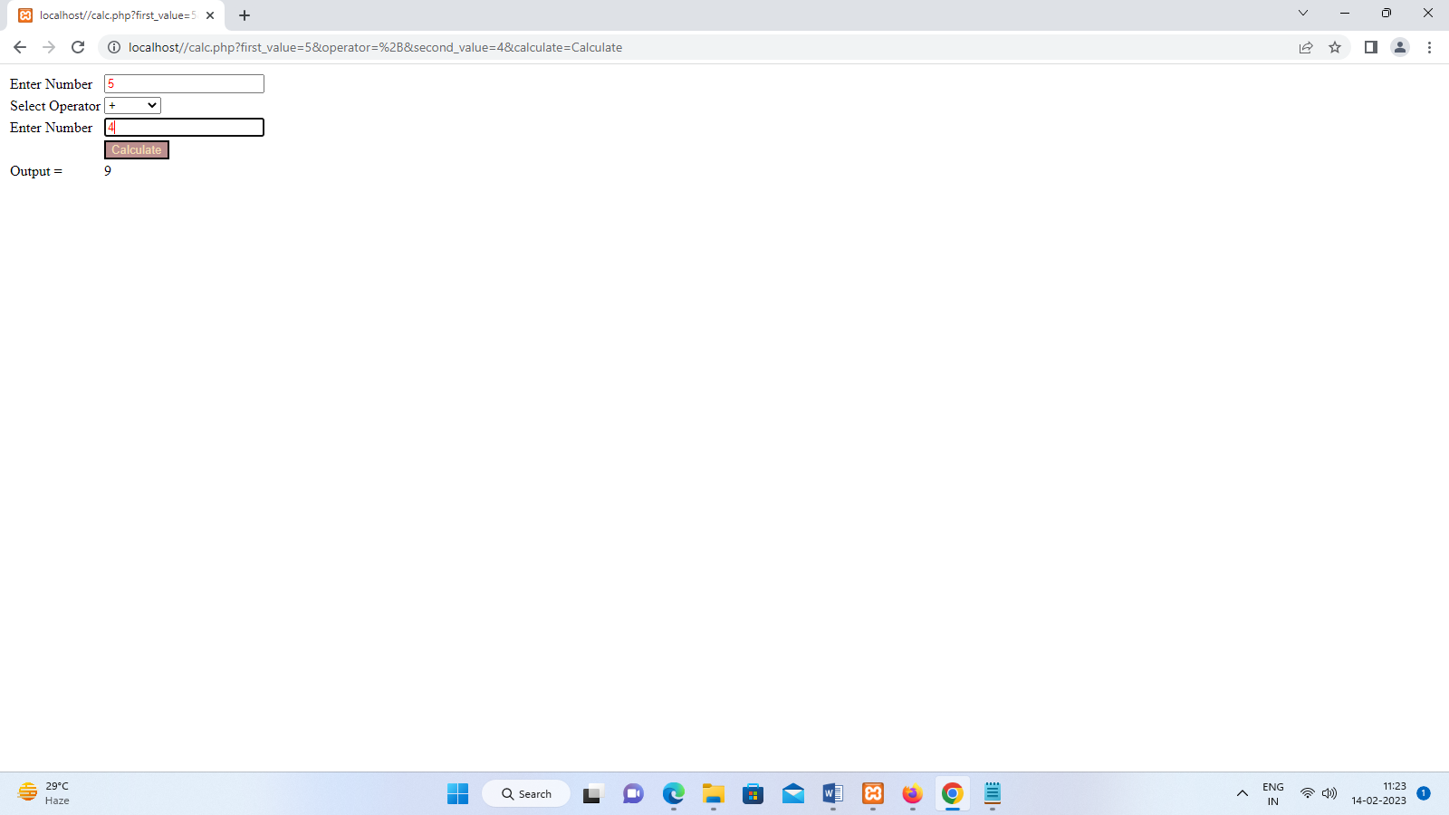

Program10

Write a PHP code to retrieve and display a result of Select query.

Program name : database.php

Database Name : studet

Table name : studentinfo

<html>

<head>

<title> display a result of Select query </title>

</head>

<body>

<h2>Student Information</h2>

<?php

if(isset($_POST['submit']))

{

$mysqli=new mysqli("localhost","root","","studet");

if($mysqli===false)

{

die("error");

}

echo'<div id="message">';

$inputerror=false;

if(empty($_POST['stu_regno']))

{

echo'error';

$inputError=true;

}

else

{

$regno=$mysqli->escape_string($_POST['stu_regno']);

}

if(empty($_POST['stu_name']))

{

echo'error';

$inputError=true;

}

else

{

$name=$mysqli->escape_string($_POST['stu_name']);

}

if(empty($_POST['stu_batch']))

{

echo'error';

$inputError=true;

}

else

{

$batch=$mysqli->escape_string($_POST['stu_batch']);

}

if(empty($_POST['stu_address']))

{

echo'error';

$inputError=true;

}

else

{

$address=$mysqli->escape_string($_POST['stu_address']);

}

if(empty($_POST['stu_phone']))

{

echo'error';

$inputError=true;

}

else

{

$phone=$mysqli->escape_string($_POST['stu_phone']);

}

if($inputerror!=true)

{

$sql="insert into studentinfo(regno,name,batch,address,phone) values('$regno','$name','$batch','$address','$phone')";

if($mysqli->query($sql)===true)

{

echo 'New student name added';

}

else

{

echo' error';

}

}

echo'</div>';

$mysqli -> close();

}

?>

<form action="database.php" method="POST">

Student Register number:<br/>

<input type="text" name="stu_regno" size="40"/><p/>

Student name:<br/>

<input type="text" name="stu_name" size="40"/><p/>

Batch:<br/>

<input type="text" name="stu_batch" size="40"/><p/>

Address:<br/>

<input type="text" name="stu_address" size="40"/><p/>

Phone Number:<br/>

<input type="text" name="stu_phone" size="40"/>

<p/>

<input type="submit" name="submit" value="submit">

</form>

</body>

</html>

**OUTPUT:**

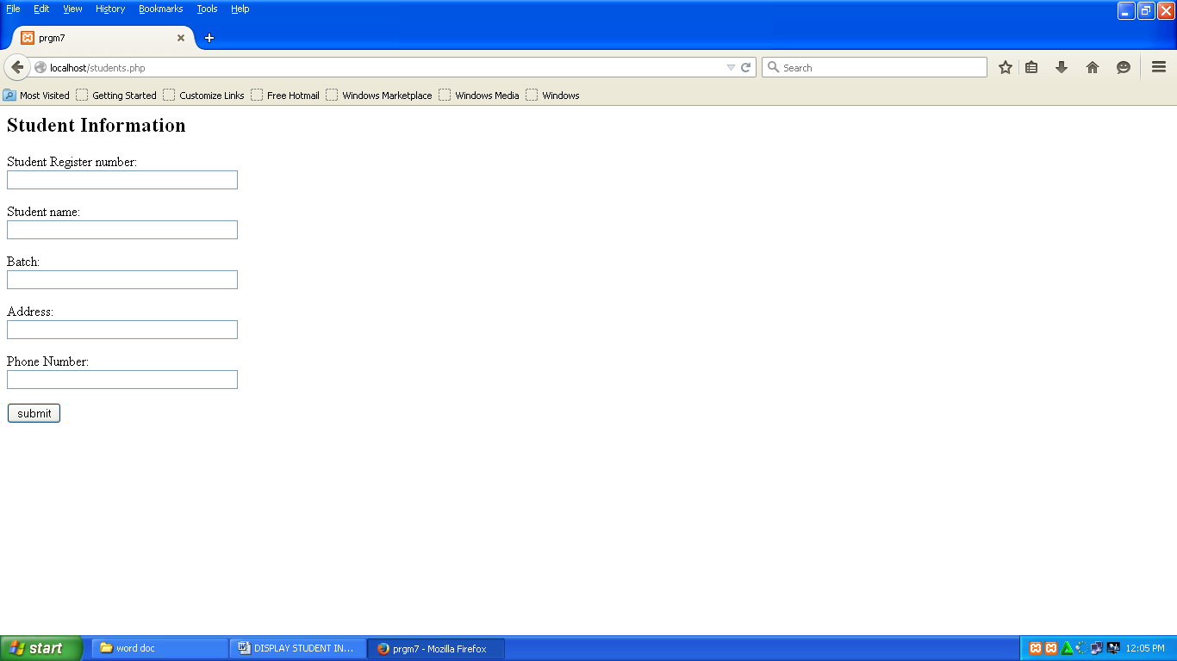

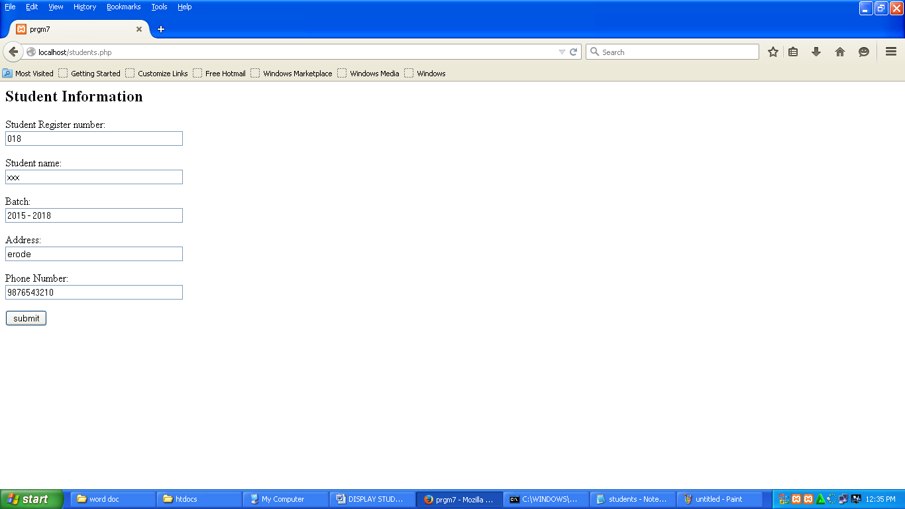

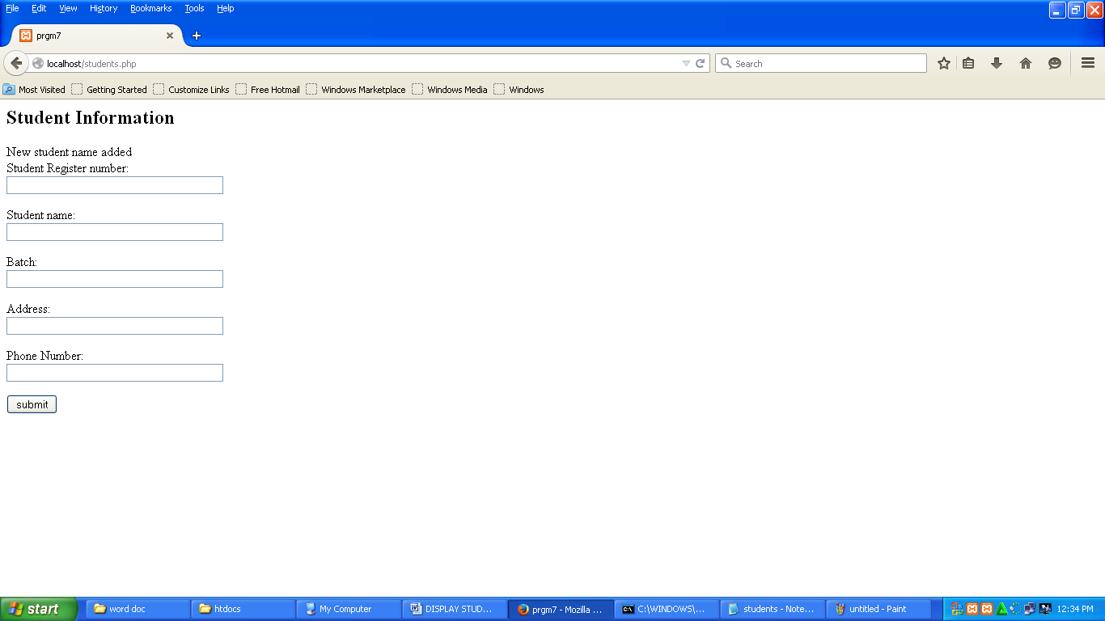

Cmd prompt :

